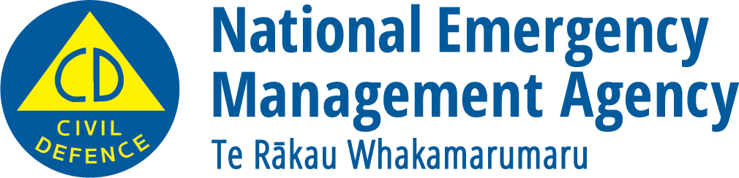
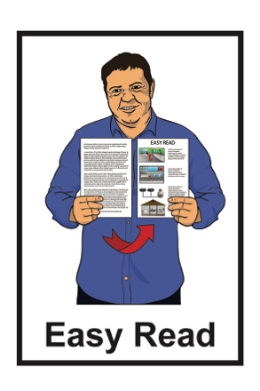

Looking after how you

are feeling

December 2022
Looking after how you are feeling

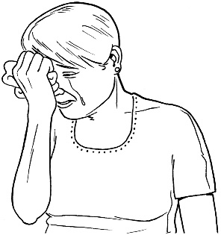
Looking after your mental wellbeing is about taking care of how well you feel.

If there is an emergency or natural disaster like an earthquake or flood you might feel:
- stressed
- anxious.

There are things you can do to look after your mental wellbeing.
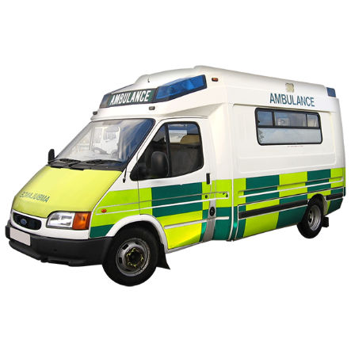

If it is an emergency like someone is badly hurt call 111 for an ambulance.

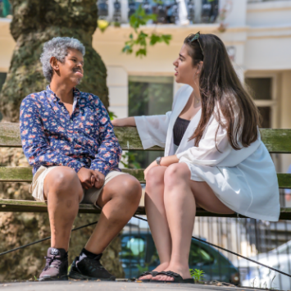
After a natural disaster it is good to talk to someone about how you are feeling.

Some people may feel okay after a disaster.

Some people may feel okay at first but start feeling bad later.

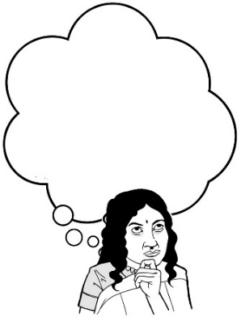
You may feel okay most of the time but get upset when something makes you think about the disaster.

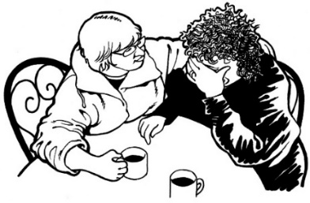
You can talk about how you feel with your:
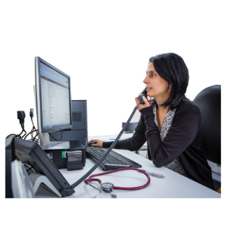
- family / friends

- Doctor.

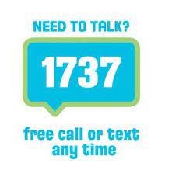
You can also call or text a trained counsellor at 1737: Need to talk.

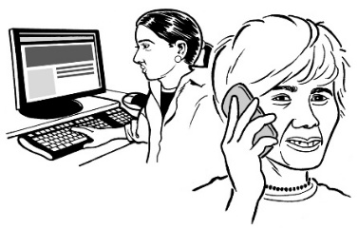
A trained counsellor is someone who can help you talk about your feelings.

You can talk to a trained counsellor at 1737: Need to talk by:
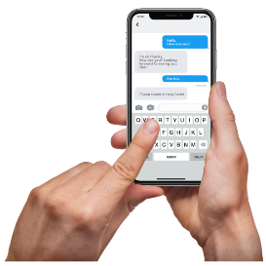
- calling: 1737

- texting: 1737.

1737: Need to talk is free to call or text.

This means it will not cost you any money to call or text 1737: Need to talk.

This information has been written by National Emergency Management Agency.
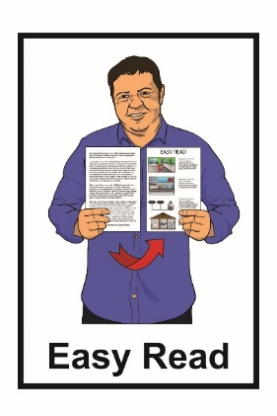
It has been translated into Easy Read by the Make It Easy service of People First New Zealand Inc. Ngā Tāngata Tuatahi.

The ideas in this document are not the ideas of People First New Zealand Inc. Ngā Tāngata Tuatahi.
Make It Easy uses images from:

- Changepeople.org
- Photosymbols.com

- Sam Corliss
- Huriana Kopeke-Te Aho

All images used in this Easy Read document are subject to copyright rules and cannot be used without permission.

