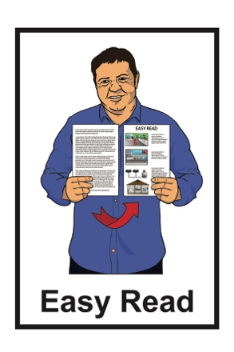

What you can do to be ready

for landslides

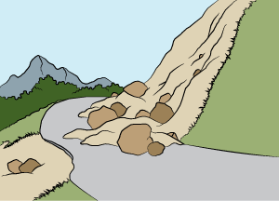

December 2022

What you will find in here

Page number:

What is a landslide? 2

Things you can do to be ready
for a landslide 4

The warning signs of a landslide 9

What to do if a landslide
happens 13
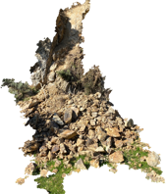

What to do after a landslide 16

What to do if your property is damaged by a landslide 19

What is a landslide?

The information in this booklet is about being ready for if a landslide happens.

A landslide is when a large amount of land moves down a slope.

A landslide can be made of:

- rocks / rubble

- soil / earth.

Landslides can be caused by things like:

- heavy rain
- earthquakes.
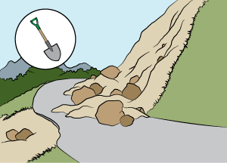
Sometimes landslides can be caused by things that people have done.

All landslides can be very dangerous.

If a landslide happens:

- it can cause a lot of damage
- it can put people in a lot of danger.

It is not possible to know when a landslide might happen.

There are things we can do to:

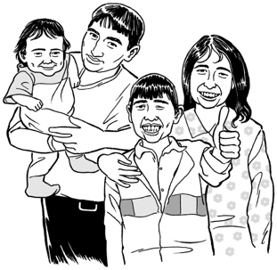
- be ready if a landslide happens

- protect ourselves / our family.

Things you can do to be ready for a landslide

The best way to get ready for if a landslide happens is to make a plan.

Having a plan will make it easier for you to know what to do if a landslide happens.

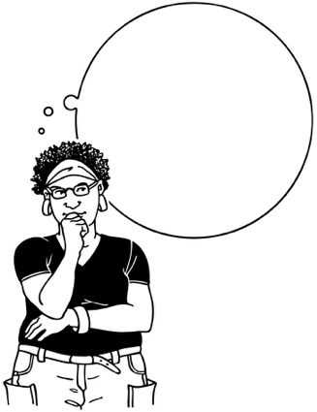
It is important to practise what you will do in a landslide so you can act quickly to keep yourself safe if it happens.

Practise is when you do something many times so that you can get good at doing it.

It is a good idea to find out what the landslide risk is like where you live.

The landslide risk will tell you how likely it is a landslide will happen.

You can find out what the landslide risk is for where you live by asking your local Civil Defence Emergency Management Group for more information.

Places that tend to be more at risk from landslides are usually:
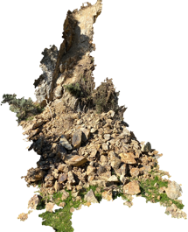
- places that have had landslides before

- places near steep slopes

- places that have drainage channels on steep slopes.
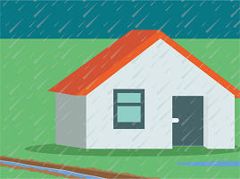
A drainage channel is a way of helping water to drain away off the land.

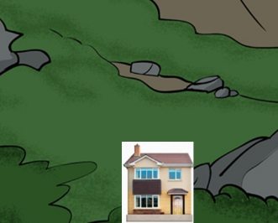
Other areas that are likely to see landslides are places near water such as:

- near the sea / cliffs
- near rivers

- near streams.

If you have house insurance you should make sure it is up to date.

Having insurance is when you pay money to an insurance company so they will assist you if something goes wrong.

You should make sure you have insurance for:

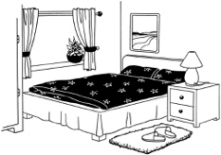
- your home

- the things you have inside your home known as contents.

Having insurance will help you get things fixed sooner if your house is damaged by a landslide.

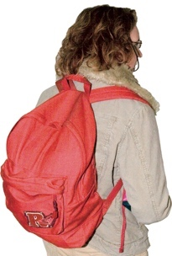
It is a good idea to put together a grab bag that you can take with you in an emergency.

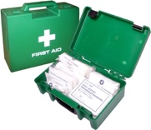
A grab bag is a small backpack of essential items that you can take with you if you need to get away from danger very quickly.

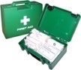
It is also a good idea to think about what supplies you might need.

Supplies can be things like:

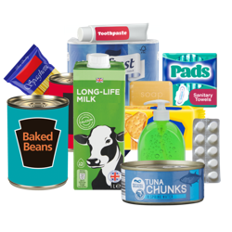
- a stock of bottled water for everyone in your house

- a cupboard stocked with food
- a torch with extra batteries
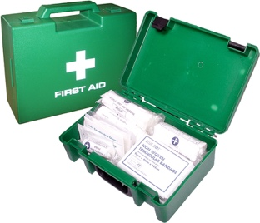
- a first aid kit.

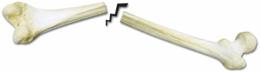
First aid is when you give medical help to someone who is injured so you can:
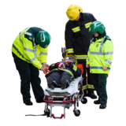
- save the life of that person

- prevent their injury from getting worse.

The warning signs of a landslide

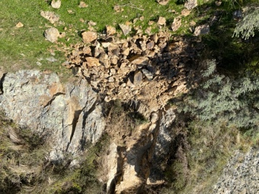
You should know what the warning signs of a landslide look like so you can act quickly if you see them.

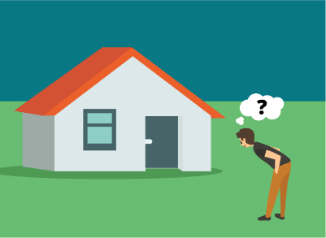
You should check inside and outside your house often for any changes

You should make sure you check:

- after any long dry weather
- after an earthquake
- after a lot of heavy rain.

The kinds of things you should look for include:

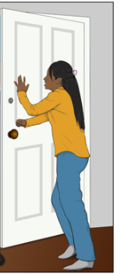
- signs of small slips such as a collection of rocks at the bottom of a slope

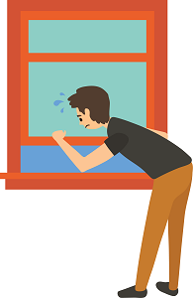
- doors that do not open easily / get stuck

- windows that do not open easily / get stuck

- gaps that show window frames / door frames are not fitting properly

- anything that looks like it is leaning to one side such as:
- trees

- walls

- fences.
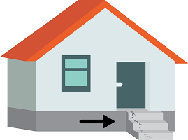
Other warning signs you should look out for are things like structures you might have outside your house that have moved such as:

- steps
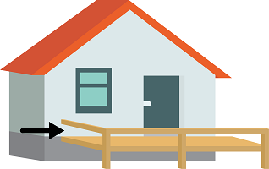
- decks

- balconies.

You should also check for any changes in places such as:

- the ground your house is built on

- outside walls that are a part of your house

- nearby roads

- footpaths next to your house.
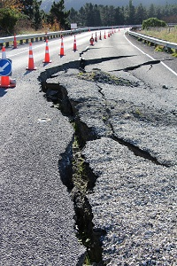
The types of changes you should check for include things like:

- new cracks

- new bulges

- other unusual changes.

When you are out driving you should watch out for any fallen rocks that show a slip has happened in places such as on the:
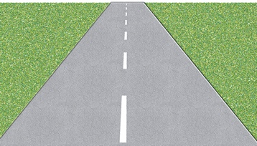
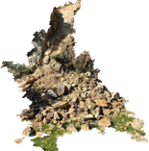
- road

- pavement

- land at the sides of the roads.

What to do if a landslide happens
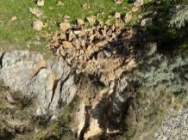

If a landslide happens you should get out the way as quickly as you can.

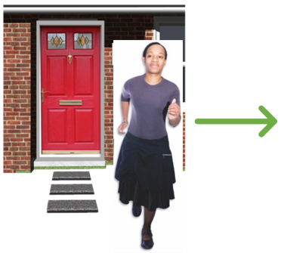
If the building you are in is in danger you should evacuate straight away.

Evacuate means to get to a safe place away from danger.

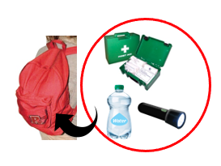
You should have your grab bag ready in case you need to evacuate.

You should make sure you follow any instructions given to you by emergency services.

You should follow any orders that tell you to evacuate to stay safe.
Safe place

You should evacuate straight away if you do not feel safe even if you have not been told to.

If you have to leave your home you should take your pets with you.

It is important to keep up with any information that will make sure you can stay safe.

You should listen to local news stations on a battery powered radio for more warnings.

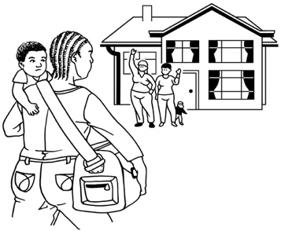
If it is safe to do so you should check on people nearby who might need your help such as:
- your neighbours

- older / disabled whānau
- anyone else who might need your support.

What to do after a landslide

After a landslide has stopped you should always be ready for more to happen.

You should stay away from any areas that have had a landslide until you have been told it is safe.

You should not go back to your home after a landslide until you have been told it is safe.

This is because more landslides could happen in the same area which could be very dangerous.

You should report any damage the landslide has done to:

- emergency services

- your local council.

A landslide can damage the utilities that connect to your house.
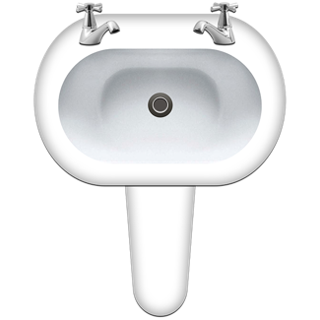
Utilities are things like:

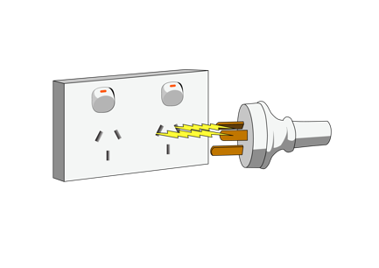
- the water that comes out of your taps

- your electricity supply
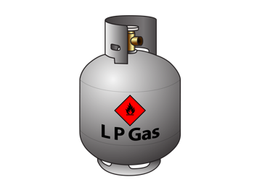
- your gas supply.

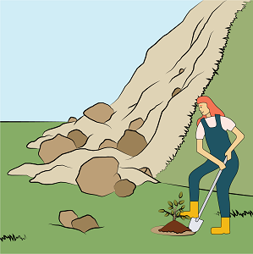
You should try to replant any ground that has been damaged by a landslide as soon as you can.

Replant means to replace any:
- trees

- grass

- bushes.

This is because bare ground that has lost cover can slip more easily.

You should check if people nearby need your help such as:
- your neighbours

- older / disabled whānau.

What to do if your property is damaged by a landslide

It is possible that a landslide could damage your property.

Your property could be things like:

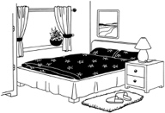
- the outside of your house

- things inside your house

- your car

- things in your garden such as sheds.

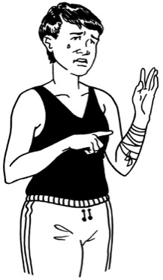
If your property is damaged by a landslide you should not do anything that could:

- put you in danger
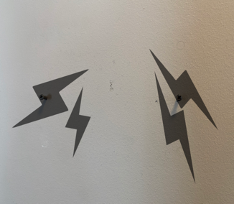
- cause more damage to your property.

If you have insurance you should tell the insurance company about the damage the landslide has done as soon as possible.

If you rent your home you should tell your landlord about the damage as soon as possible.

You should take photos of any damage caused by a landslide.

Having photos will mean that the insurance company can look at your insurance claim much faster.

This information has been written by the National Emergency Management Agency.
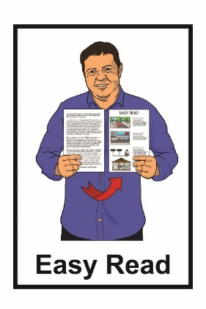
It has been translated into Easy Read by the Make It Easy service of People First New Zealand Inc. Ngā Tāngata Tuatahi.

The ideas in this document are not the ideas of People First New Zealand Inc. Ngā Tāngata Tuatahi.
Make It Easy uses images from:

- Changepeople.org

- Photosymbols.com
- Sam Corliss
- Huriana Kopeke-Te Aho.

All images used in this Easy Read document are subject to copyright rules and cannot be used without permission.

