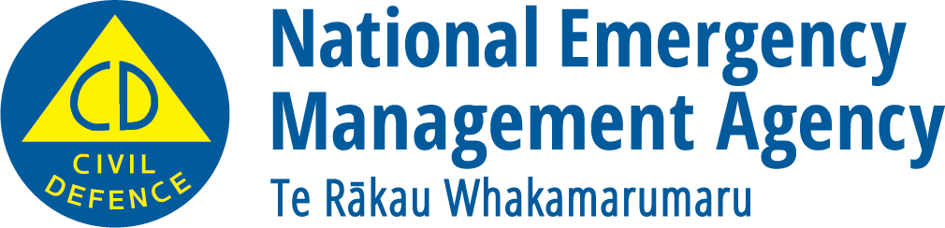
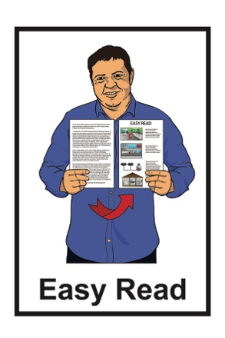

Who does what in an emergency?
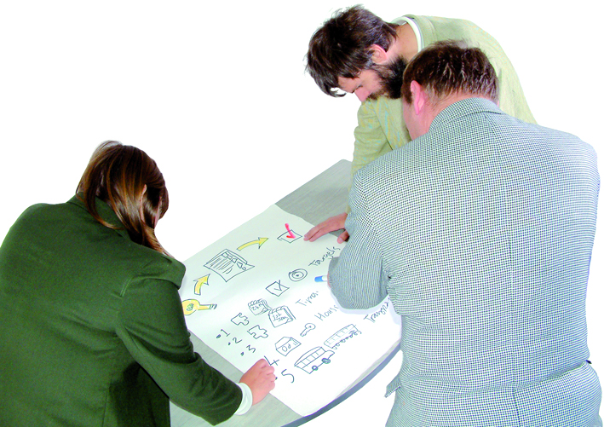

December 2022

What you will find in here

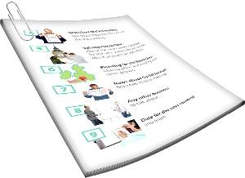
Page number:

About this document 2
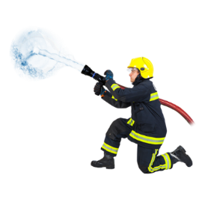

Small emergencies 3

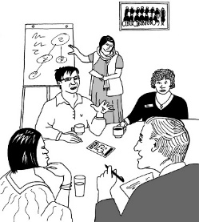
State of Local Emergency 5

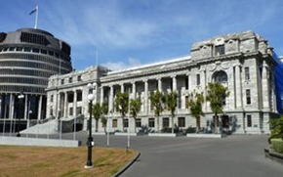
State of National Emergency 7

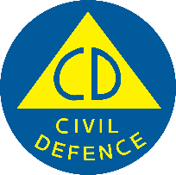
Other work by CDEM Groups 8

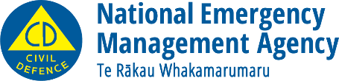
National Emergency
Management Agency 10

About this document

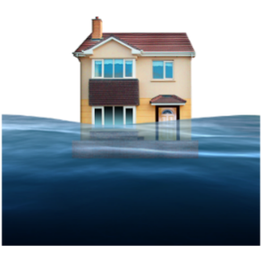

Emergencies are things like:
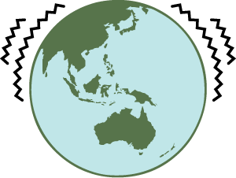
- floods
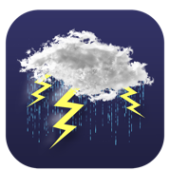
- earthquakes
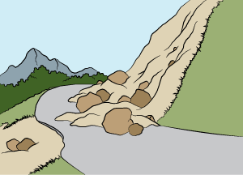
- storms
- landslides

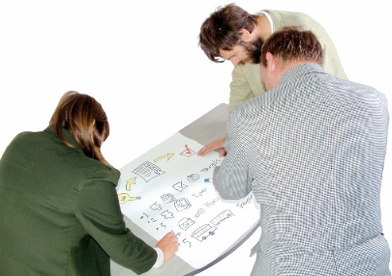
There are:
- different kinds of emergencies
- different organisations that deal with emergencies.

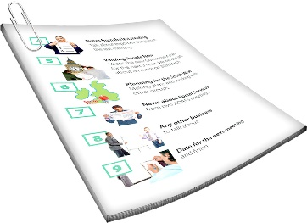
This Easy Read document is about who does what in different kinds of emergencies.

Small emergencies

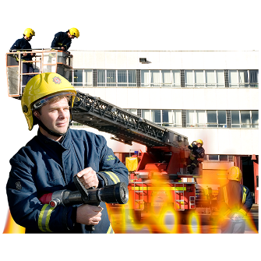

Many small emergencies can be dealt with by emergency services.
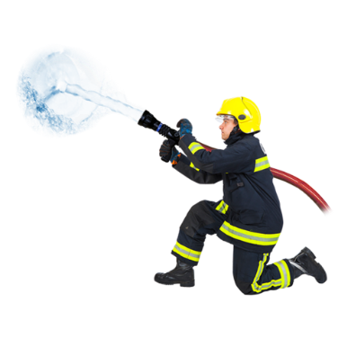

For example Fire and Emergency New Zealand if a house catches fire.

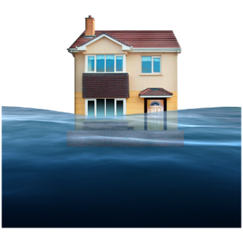
There are also small to medium emergencies like floods.

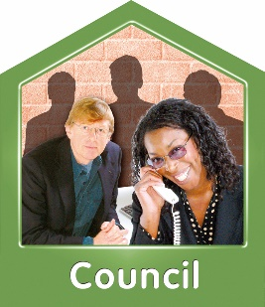
These can be managed by your local:
- council
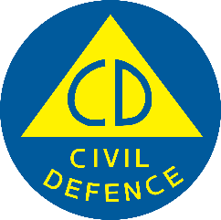
- Civil Defence Emergency Management Group.

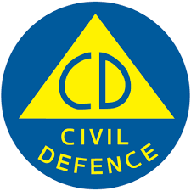
Civil Defence Emergency Management Groups are made up of people from different councils in your area.

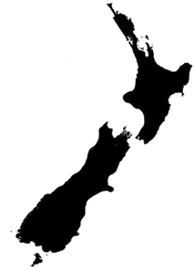
In this document we will call them CDEM Groups for short.

There are 16 CDEM Groups in New Zealand.

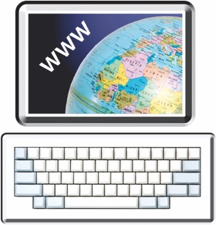
You can find more information about the CDEM Groups on this website:

www.civildefence.govt.nz

State of Local Emergency

Some emergencies need extra work to make sure different services work together well.

In this case someone from the CDEM Group may say there is a State of Local Emergency.

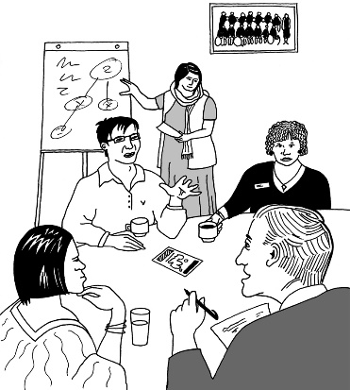
This means the CDEM Group has more powers to deal with the emergency.

When there is a State of Local Emergency the CDEM Group is in charge of dealing with the emergency.

This means things like:
- organising other emergency services
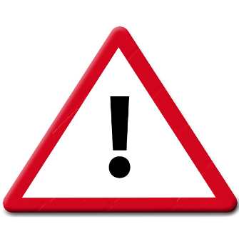
- telling people what is happening
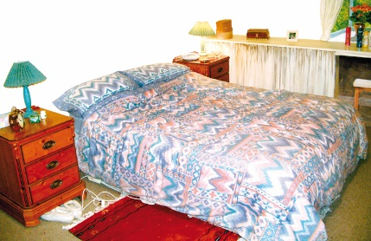
- making sure people cannot go in dangerous places
- making sure people have the things they need like
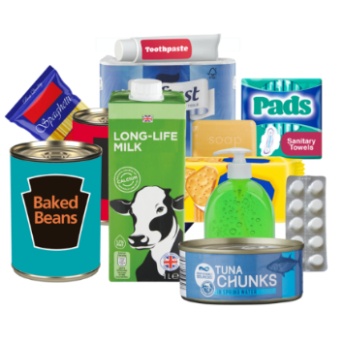
  - a place to stay
  - food
  - water.

State of National Emergency

If there is a very big emergency the Minister for Emergency Management can say it is a State of National Emergency.

The Minister for Emergency Management is the person in Government who makes some of the decisions about emergency management.
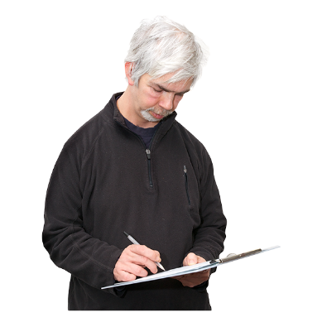

In this case the Director of Civil Defence Emergency Management is in charge.

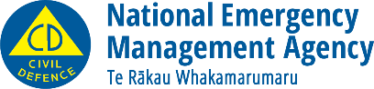
The National Emergency Management Agency / NEMA organises the work on the emergency.

Other work by CDEM Groups

When there is not an emergency CDEM Groups work on building resilient communities.

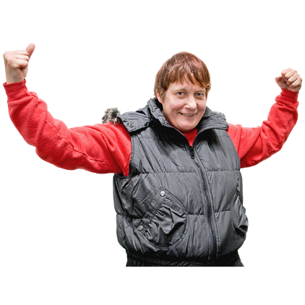
Resilient communities are ones that can deal well with bad things happening.

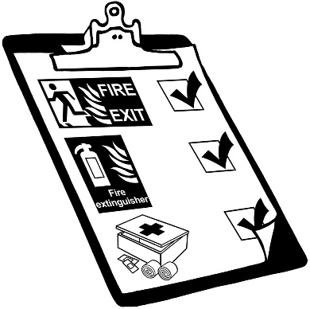
This work includes:
- planning for emergencies
- working on making things better
after an emergency
- working to reduce risks and hazards.

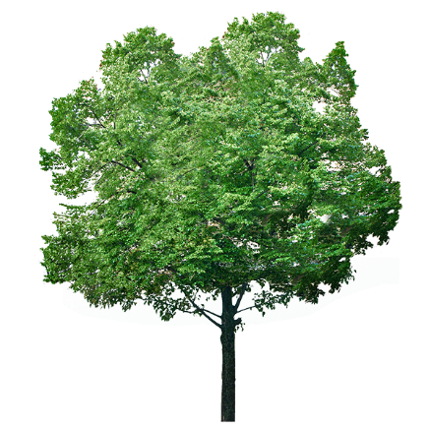
Risks and hazards are things that can go wrong like:

- a tree that might fall down
- a place a river might flood.
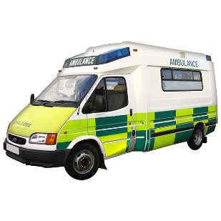

CDEM Groups work closely with:
- emergency services like fire and ambulance
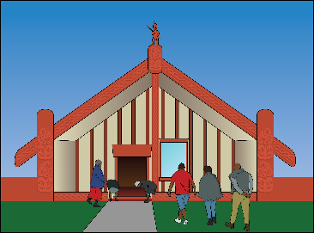
- government departments
- iwi
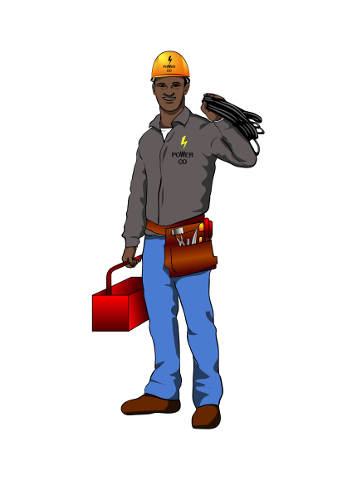
- essential services like power or phone / internet
- others who support people in emergencies.

National Emergency Management Agency

The National Emergency Management Agency is called NEMA for short.

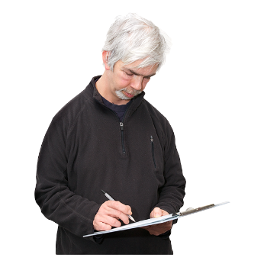
It looks after the New Zealand Emergency Management system which means:
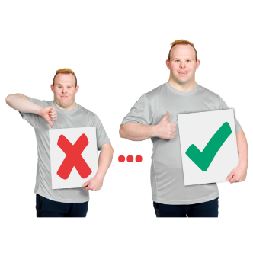
- making sure it works how it should
- finding ways of making it better.

This information has been written by the National Emergency Management Agency.
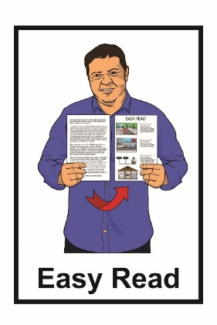
It has been translated into Easy Read by the Make It Easy service of People First New Zealand Inc. Ngā Tāngata Tuatahi.

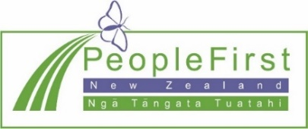
The ideas in this document are not the ideas of People First New Zealand Inc. Ngā Tāngata Tuatahi.
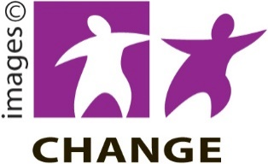
Make It Easy uses images from:

- Changepeople.org
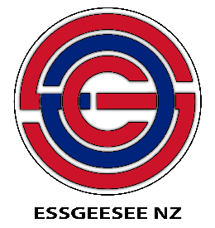
- Photosymbols.com

- Sam Corliss
- Huriana Kopeke-Te Aho.

All images used in this Easy Read document are subject to copyright rules and cannot be used without permission.

