When an earthquake happens
Civil Defence

Produced 2022 by Accessible Formats Service, Blind Low Vision NZ,
Auckland
Total print pages: 2
Total large print pages: 3

Notes for the Large Print Reader
Print page numbers are indicated as:
Page 1
Main text is in Arial typeface, 18 point.

Page 1

When an earthquake happens
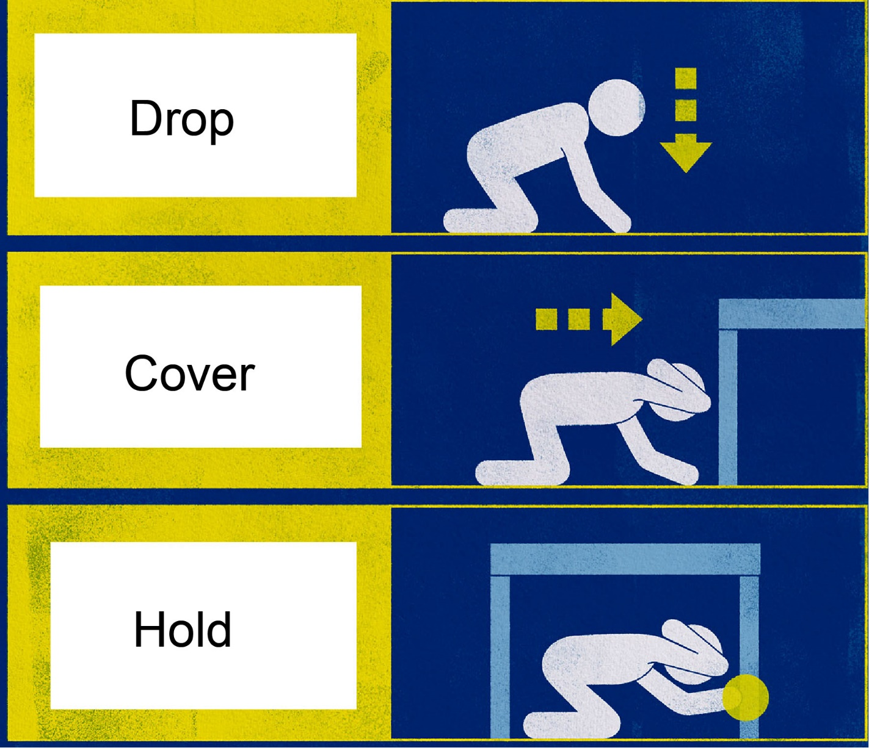
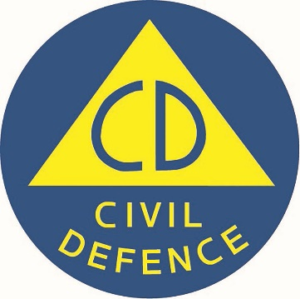
Logo: Civil Defence
www.civildefence.govt.nz
Page 2

When an earthquake happens

Drop, Cover, Hold
All of New Zealand is at risk of earthquakes. Knowing the right immediate action to take can prevent injury and save lives.
In an earthquake, Drop, Cover, Hold. It stops you being knocked over, makes you a smaller target for falling and flying objects, and protects your head, neck and vital organs.
- DROP down on your hands and knees. This protects you from falling but lets you move if you need to.
- COVER your head and neck (or your entire body if possible) under a sturdy table or desk (if it is within a few steps of you). If there is no shelter nearby, cover your head and neck with your arms and hands.
- HOLD on to your shelter (or your position to protect your head and neck) until the shaking stops. If the shaking shifts your shelter around, move with it.
If there is no shelter near you, crawl to an inside corner of the room and cover your head and neck with your hands and arms. Do not run outside or stand in a doorway. Many people are injured while trying to move DURING the shaking. It is safer to Drop, Cover, and Hold until the shaking is over.
Make a plan today. Find out who can help you and who might need your help. Your local Civil Defence Emergency Management Group has information for your region.
civildefence.govt.nz

