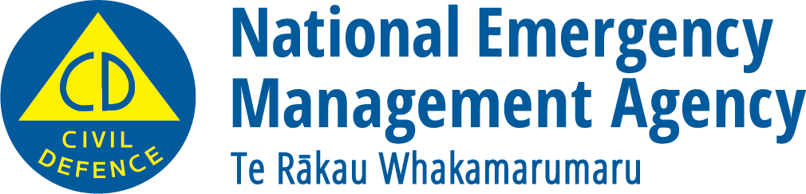
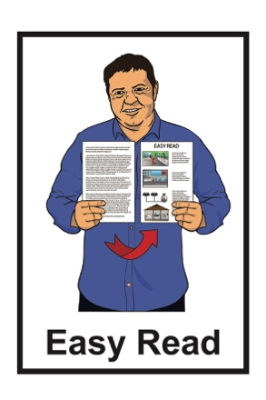

Things you can do to be ready for an emergency

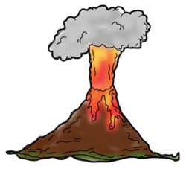
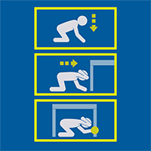
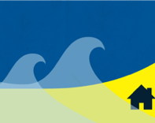

December 2022

Before you start reading

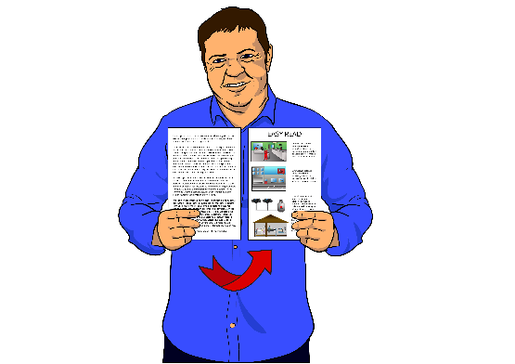
This is a long document.

While it is written in Easy Read it can be hard for some people to read a document this long.

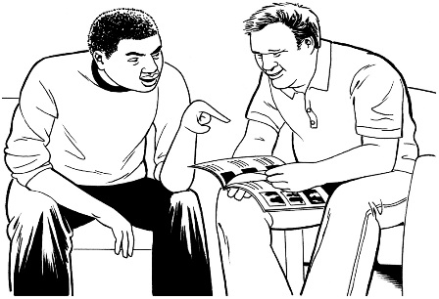
Some things you can do to make it easier are:

- read it a few pages at a time

- have someone help you to understand it.

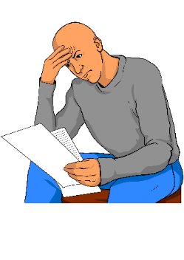
Some of the information in this booklet might worry you.

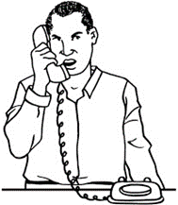
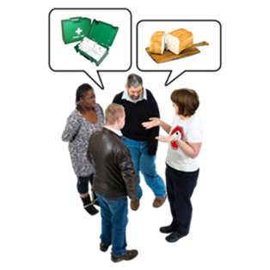
If you are worried about anything you read in this booklet you could talk about it with:
- your family

- your friends.

What you will find in here

Page number:
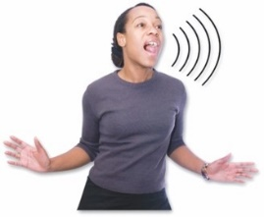

What is an emergency? .5
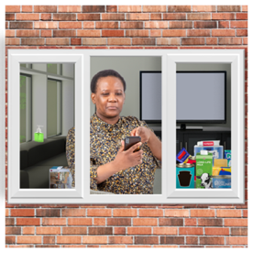

If you are stuck at home in an emergency .7
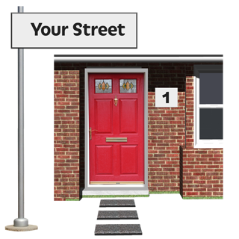

If you cannot get home in an emergency 15

If you have to evacuate in an emergency 20

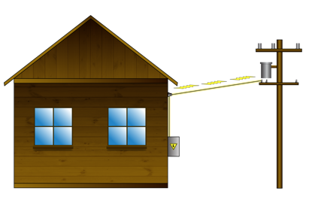
If the power is cut off in an emergency 25

Page number:

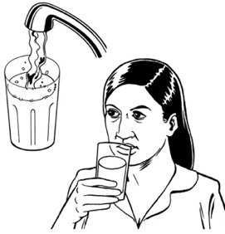
If you have no water in an
emergency 30

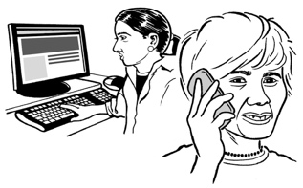
If you have no phone or internet
in an emergency 36

What is an emergency?

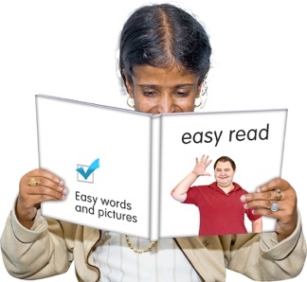
The information in this Easy Read booklet is about:
- being ready for an emergency
- what you should do if an emergency happens.

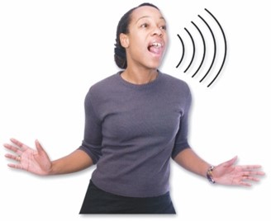
An emergency is when something dangerous happens that can put people at risk.
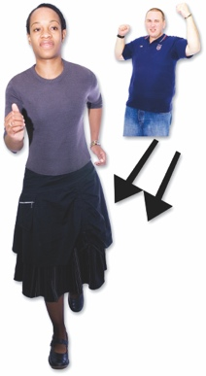
When an emergency happens everyone needs to act quickly so they can stay safe.

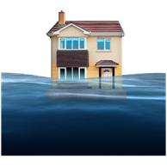
An emergency can be things like:

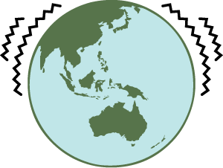
- a flood

- an earthquake
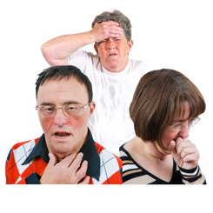
- a pandemic which is when a lot of people get very sick very quickly.

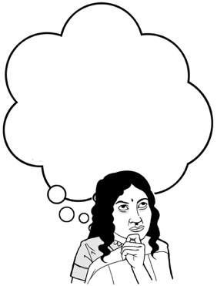
Knowing what to do in an emergency will make it much easier for you to get through it.

You should:
- talk with the people you live with / your whānau about what you should do in an emergency
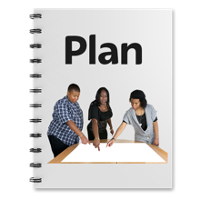
- make a plan for what you will do if an emergency happens.

If you are stuck at home in an emergency

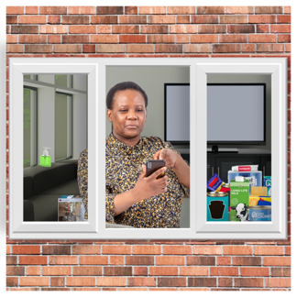
When an emergency happens it is best to stay in your own home:

- if you can

- if it is safe to do so.

Sometimes this could mean you will be at home with no:
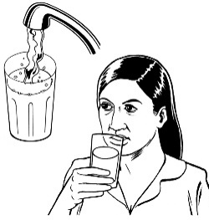
- power / electricity

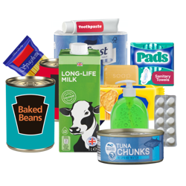
- water
- food
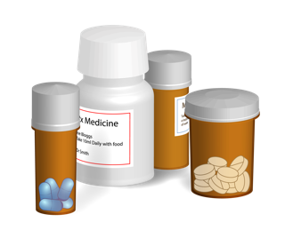
- medicine.

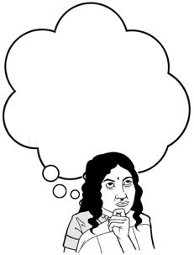
It is a good idea to think about what supplies you might need.

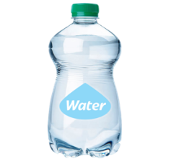
Supplies could be things like:

- a stock of bottled water for everyone in your house

- a cupboard stocked with food
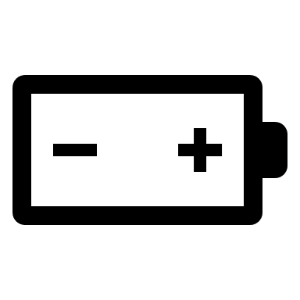
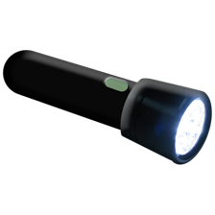
- a torch with extra batteries
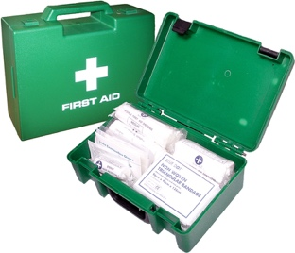
- a first aid kit.

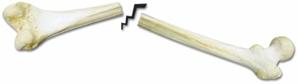
First aid is when you give medical help to someone who is hurt so you can:
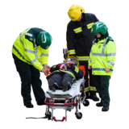
- save the life of that person

- stop them from getting worse.

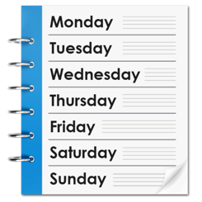
If the emergency is very bad you may have to stay at home without a way to get supplies for at least 3 days.

Things to think about

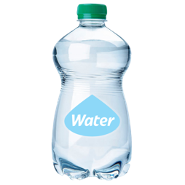
If an emergency happens:

- do you have enough food and water supplies for everyone?
- do you / your whānau have all the medicine you need?
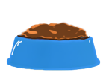
- do you have enough food and water for your pets / other animals?

Things you can do if you are stuck at home in an emergency

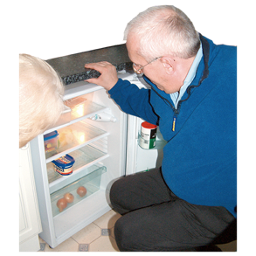
It is a good idea to have your emergency supplies in 1 place so you can find them easily.

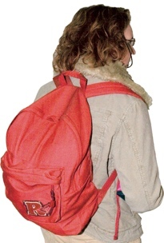
Some people like to put their emergency supplies together in a kit / bag.

It is important that everyone in the house knows where to find the emergency supplies.

If the power / electricity goes off you might have to find things in the dark.

Make sure everyone in the house knows where they can find:
- a torch
- spare batteries.

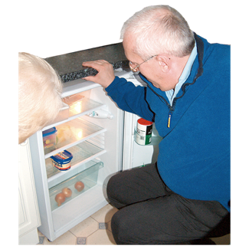
If the power / electricity goes off you should:
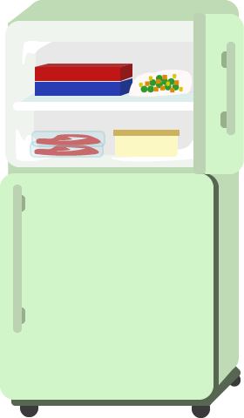
- eat the food from your fridge first
then
- eat the food from your freezer
then
- eat the food in your:

- cupboard

            - emergency supplies.
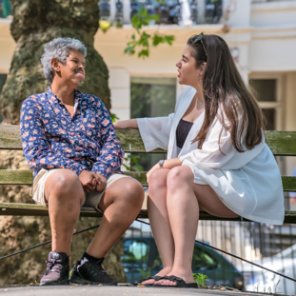
It is a good idea to get to know your neighbours.

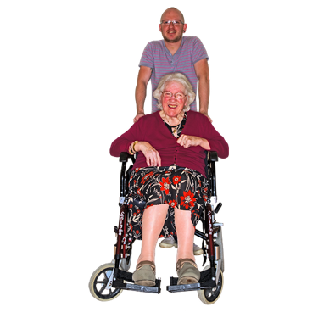
In an emergency:

- you might need support

- other people might need support.

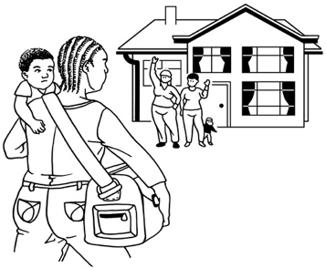
In an emergency you should check in with other people such as:

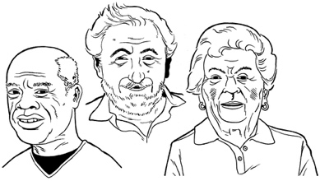
- your neighbours

- older / disabled whānau
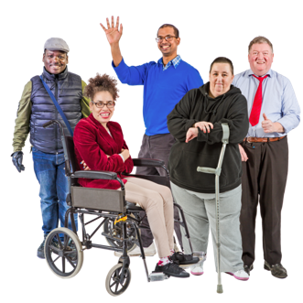
- anyone else who might need your support.

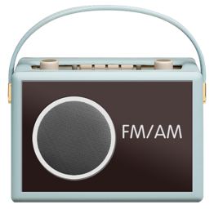
You should listen to the radio so you know what is happening.

It is a good idea to have a radio that is:

- powered by batteries
or

- solar powered which means the solar batteries are recharged by sunlight.

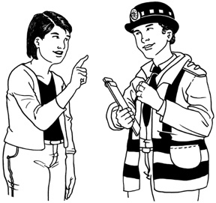
You should follow instructions from official sources in an emergency.

Official sources might be:

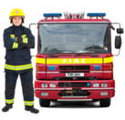
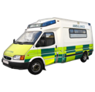
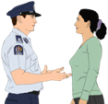
- your local council

- emergency services
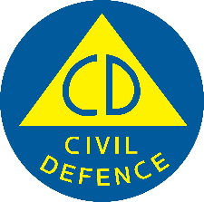
- your local Civil Defence Emergency Management Group.

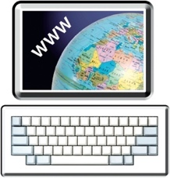
You can find information from official sources online at:

- their websites

- their social media pages like:

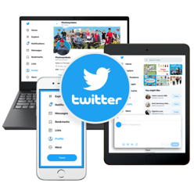
- Facebook
- Twitter.

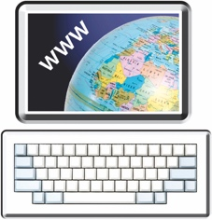
You can find the Civil Defence Emergency Management Group for your local area at this website:

https://www.civildefence.govt.nz

If you cannot get home in an emergency

If an emergency happens you might not be able to get home.

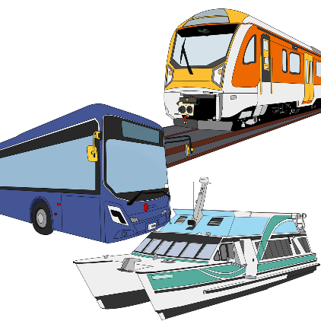
Public transport might stop running like:
- buses
- trains.

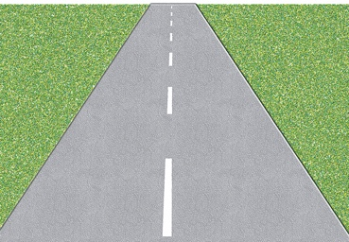
Road Closed
Roads might be blocked / closed so you cannot use them.

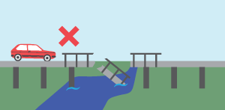
Sometimes areas might be blocked / closed so you cannot get to them at all.

Things to think about
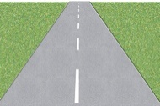
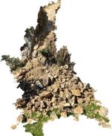
If an emergency happens:
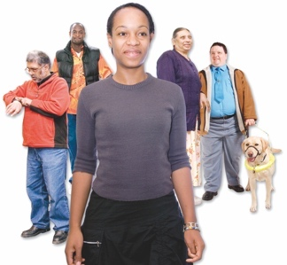
- how will you get home if you cannot take your usual way of getting home?

- will anyone else go home with you?
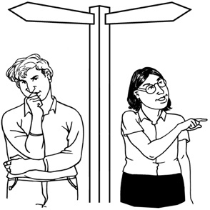
- where will you go / meet up with people if you cannot get home at all?

Things you can do if you cannot get home in an emergency

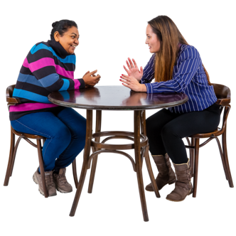
You should talk to the people you live with so you know where you can go / meet if you cannot get home.

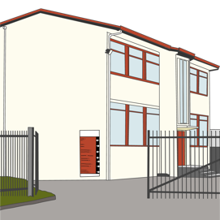
Places that you can go to / meet up with other people might be:
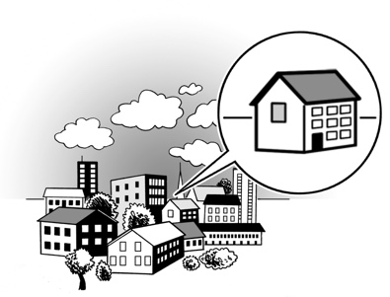
- a school
- the home of a friend
- the home of a family member.

Ask your workmates:
- if they live near you
- if you can travel home with them.

You should keep a grab bag:

- at work
- in your car.

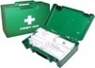
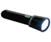
A grab bag is a small backpack of essential items.

Your grab bag should include:
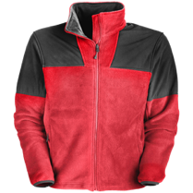
- sturdy shoes that you can walk in
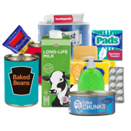
- warm clothes
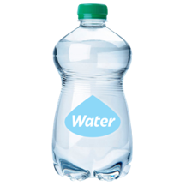
- some food / snacks
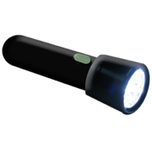
- a bottle of water
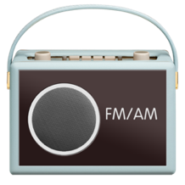
- a torch and spare batteries
- a radio.

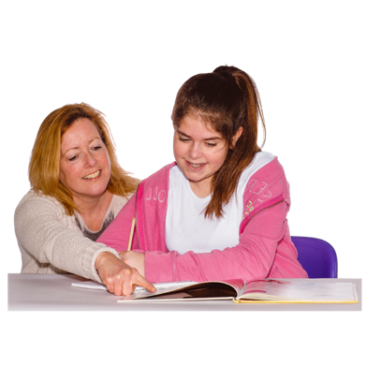
If you have children in school / an early childhood centre you should think about who will go to them if you cannot.

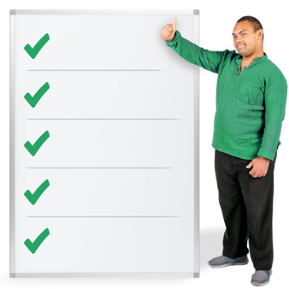
Give the school / early childhood centre a list of 3 people you trust who can pick your children up for you.

If you have to evacuate in an emergency

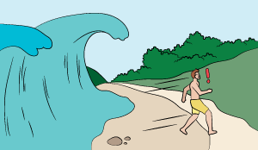
Evacuate means to get to a safe place away from danger.

In an emergency you might have to leave home very quickly to stay safe.

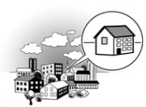
Things to think about
If you need to evacuate:
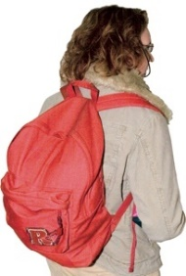
- where will you go?
- what will you take with you?
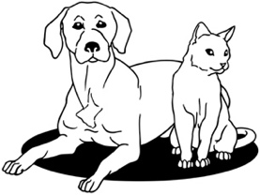
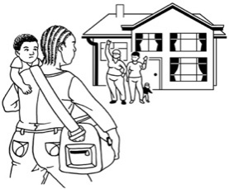
- what will you do with any pets / animals?
- do you have any neighbours who might need your support?

Things you can do if you have to evacuate in an emergency

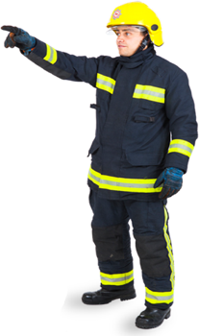
If you are told by official sources to evacuate you must do so.

Official sources might be:

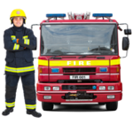
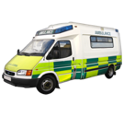
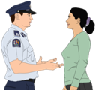
- your local Civil Defence Emergency Management Group

- emergency services.

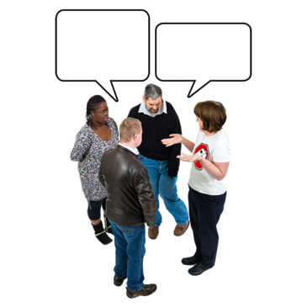
You should talk to everyone in your house about what to do if you need to evacuate.

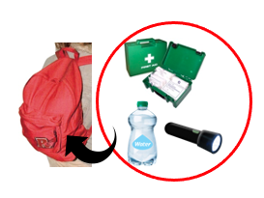
You should have a grab bag ready for everyone who lives in your house.

Your grab bag should include:

- some warm clothes

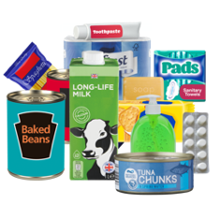
- a bottle of water
- some food / snacks
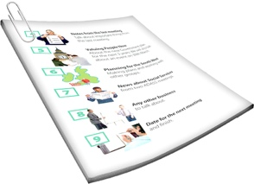
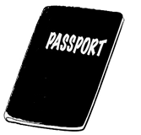
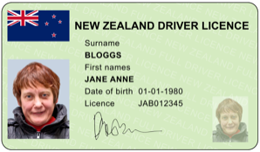
- copies of important documents like bank account / insurance details
- copies of photo ID like your passport / driver licence

- any medicine you may need.

Other things you should have are:

- a first aid kit
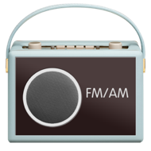
- a torch and spare batteries
- a radio.
You should keep these things in a place where you can find them quickly if you are in a hurry.

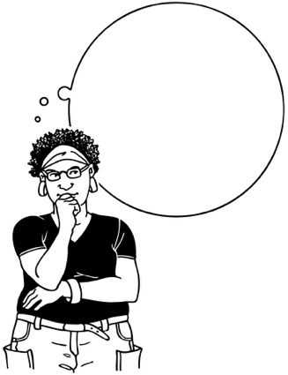
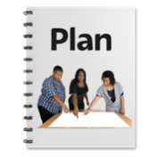
You should make a plan with everyone who lives in your house so you all know where to go if you have to evacuate.

This is called your evacuation place.

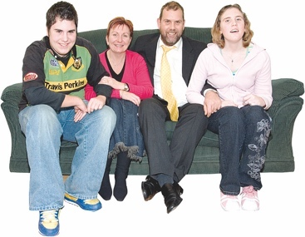
It is likely your evacuation place will be with:
- family
- friends.

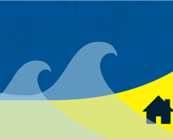
If you live in a place that is at risk of tsunami make sure your evacuation place is not at risk.
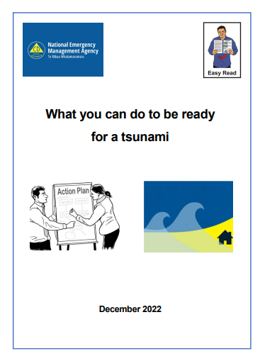
You can find out more about keeping yourself safe from a tsunami in the Easy Read document:

What you can do to be ready
for a tsunami.

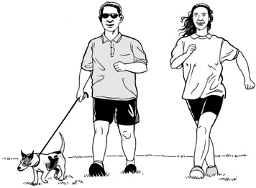
You should take your pets with you if you evacuate.

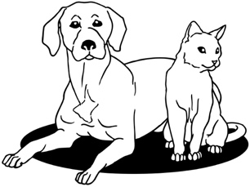
Make sure your evacuation place will allow you to bring your pets.

It is useful to keep a list of:
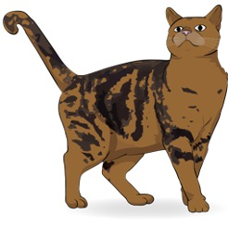
- kennels that will look after dogs
- catteries that will look after cats

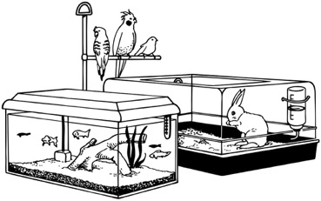
- motels that will allow you to bring pets.

If the power is cut off in an emergency

An emergency could cut off your power / electricity supply.

If this happens it could also affect:
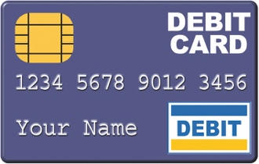
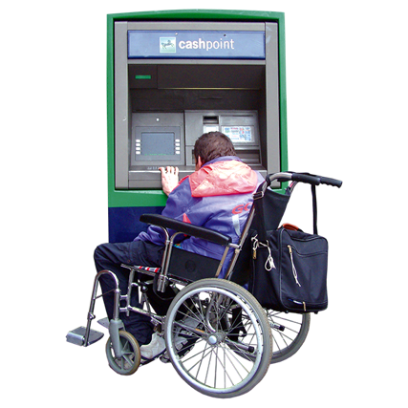
- machines you use to pay for things called EFTPOS
- machines you use to take money from your bank account called ATM.

You should make sure you have:
- some money at home
or
- enough supplies to last for at least 3 days.
Things to think about
If the power / electricity supply was cut off for many days:
- what would you do?

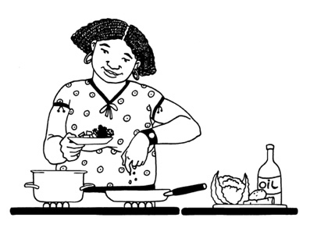
- how would you make sure you could still:
- see when it gets dark?

- cook things?
- keep yourself warm?

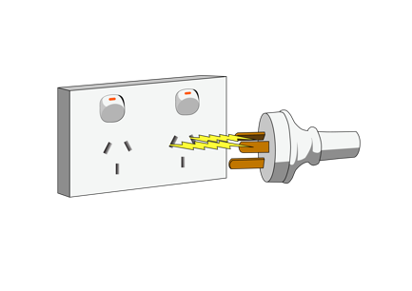
Things you can do if the power is cut off in an emergency

Make sure everyone in the house knows where they can find:
- a torch
- spare batteries.

It is a good idea to have a radio that is:
- powered by batteries

or

- solar powered.

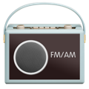
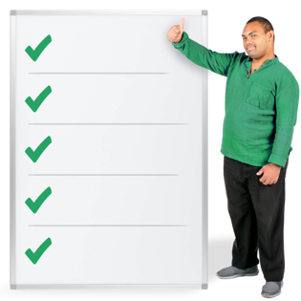
Keep a list of which radio stations to listen to for information.

Make sure you have:

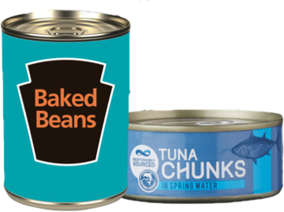
- a supply of food that does not need to be cooked like things in cans
or
- something to cook your food on like:
- a gas barbecue
- a camping stove.

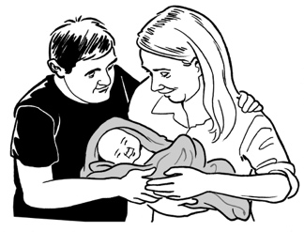
Make sure you remember to have supplies of food for:
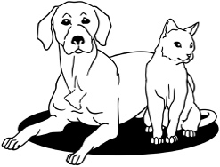
- babies
- pets / other animals.

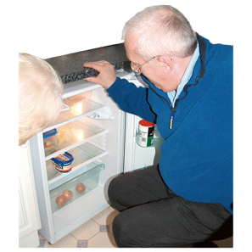
If the power / electricity goes off you should:
- eat the food from your fridge first
then
- eat the food from your freezer
then
- eat the food in your:

- cupboard

            - emergency supplies.

Talk to your neighbours about what they will do if the power is cut off.

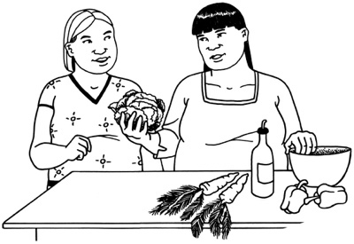
You may be able to share supplies with each other if you need to.

If you have no water in an emergency

An emergency could:

- make your water supply unsafe to use
- cut off your water supply.

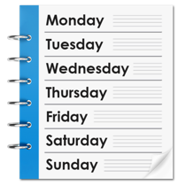
You should make sure you have a supply of water that will last you at least 3 days.

Things to think about:
What would you drink if you did not have clean water for 3 days?

Things to think about:
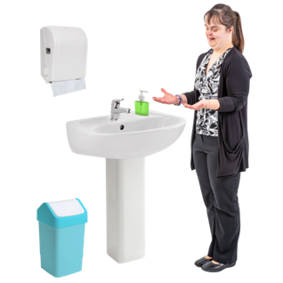
If you did not have clean water for 3 days how would you:

- wash yourself?
- wash your clothes?
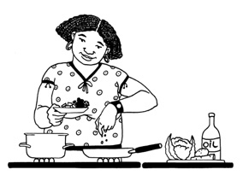
- cook things?
- wash things you have used to cook with?

Things you can do in case you have no water in an emergency
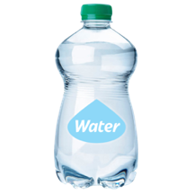

You can use clean empty plastic drinks bottles to store water.

1 person will need 3 litres of water for every day you do not have clean water.

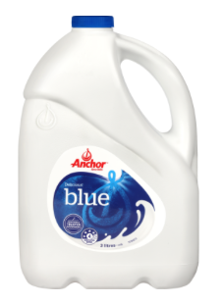
Do not use empty milk or juice bottles to store water as they are difficult to clean.

If you store water in bottles that are not cleaned properly you could get sick.

Make sure you store enough water for:
- babies
- pets / other animals.

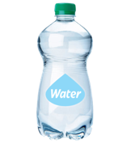
You can store drinking water for up to 1 year if you add a small amount of unscented household bleach.

You should add half a teaspoon of bleach to every 10 litres of water.

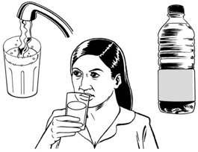
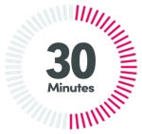
Do not drink this water for at least 30 minutes after mixing in the bleach.

20 Nov.
2022
Put a label on each bottle that says the date it was filled.

Water bottles should be stored in a place that is kept:
- cool

- dark.
You should make sure you also store plenty of water you can use for:
- cooking
- cleaning.

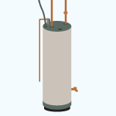
If you have a hot water cylinder you can use that water.

You should also store extra water in large plastic containers.
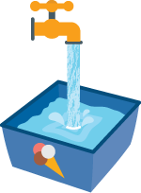

You can also fill empty plastic ice cream tubs with water.

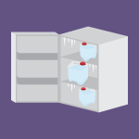
You can keep the tubs of water in the freezer.

The tubs of frozen water can be used:

- to keep food cool if the power / electricity is cut off

- for drinking.

If you have no phone or internet in an emergency

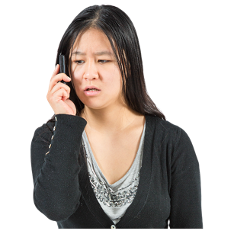
An emergency could mean you lose access to your:
- phone lines
- internet connection.

In most emergencies it is best to stay at home if it is safe to do so.

You should make your home the place where everyone in your house meets in an emergency.
Make sure everyone knows another place they can go if they cannot get home safely.

Things to think about:
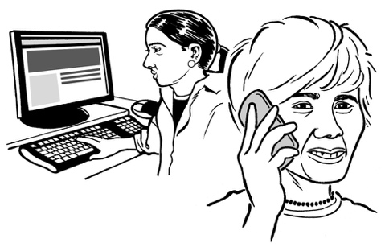
If you lose your phone / internet connection:
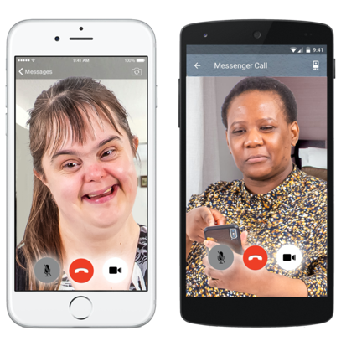
- what will you do?

- how will you:

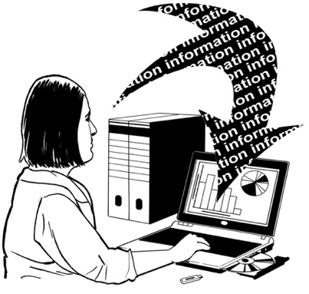
- keep in touch with people?
- meet up with other people?
- keep up with important information / updates?

Things you can do if you have no phone or internet in an emergency

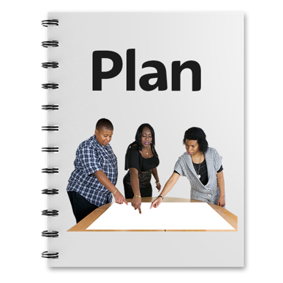
Make a plan with your family so you all know:

- how you will get in touch with each other

- where you will meet if an emergency happens.

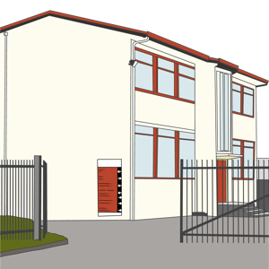
If you have children in school / an early childhood centre you should think about who will go to them if you cannot.

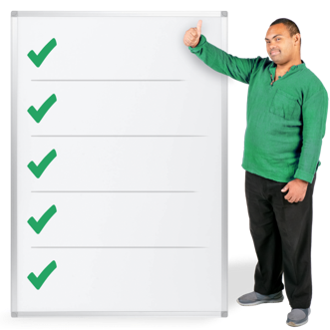
Give the school / early childhood centre a list of 3 people you trust who can pick them up for you.
It is a good idea to have a radio that is:
- powered by batteries

or

- solar powered.

Keep a list of which radio stations to listen to for information.

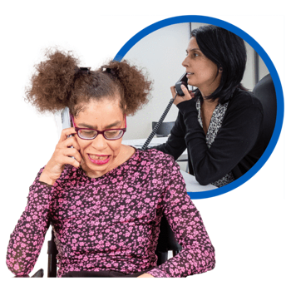
Sometimes when local phone lines are not working you can still get in touch with people outside the area where you live.

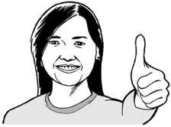
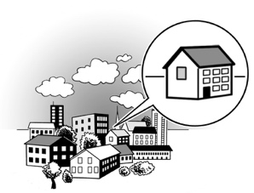
You should have someone you can contact in an emergency who does not live in your area called an out-of-town contact person.

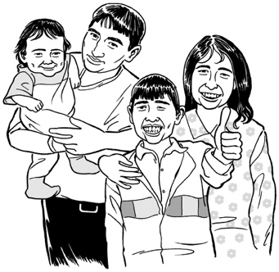
Make sure everyone in your house knows who this person is.

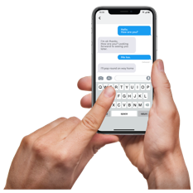
In an emergency you should get everyone to check in with your out-of-town contact person by:

- sending a text message
- sending a message online.
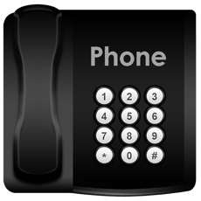

You should write down a list of important phone numbers.

Keep the list of important phone numbers in a place that means everyone in the house can find it easily.

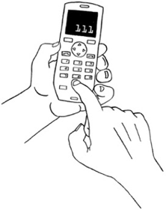
You should not use the phone in an emergency unless it is to make an emergency call to 111.

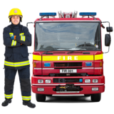
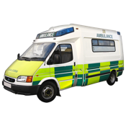
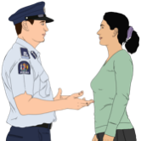
This is so that the phone lines can be kept clear for calls to emergency services.

You should use other ways of contacting other people if you need to such as:

- social media

- text messages.

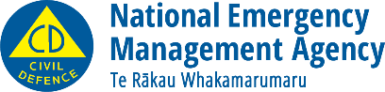
This information has been written by the National Emergency Management Agency.
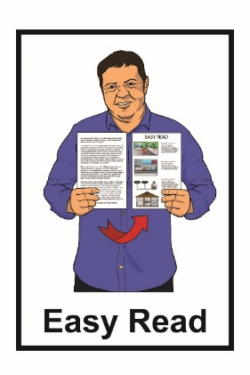
It has been translated into Easy Read by the Make It Easy service of People First New Zealand Inc. Ngā Tāngata Tuatahi.

The ideas in this document are not the ideas of People First New Zealand Inc. Ngā Tāngata Tuatahi.
Make It Easy uses images from:

- Changepeople.org

- Photosymbols.com

- Sam Corliss
- Huriana Kopeke-Te Aho

All images used in this Easy Read document are subject to copyright rules and cannot be used without permission.

